COMSATS University Islamabad

WAH Campus



**Submitted by:**

Behroze Aslam, Adnan Haider, Talha Mustaq, M.Saad Ali,Zil e Hassan Talha

**Reg no:**

SP20-BSE-057-64-076-056-092/WAH

**Class/Section:** 6/B

**Submitted to: Dr Anum Nazir**

**Date Submitted:** 25/12/2022

Question 1:

FMRI and Brain tumor detection in deep learning.

Answer:

**Dataset:** fMRI images divided into two groups training set and testing set, pictures will be shown in code section.

**Repository:** *https://github.com/barcha47/brain-tumor-detection*

**Problem Statement:**

Functional magnetic resonance imaging (fMRI) is a type of brain imaging that measures blood flow in the brain to detect areas of activity. It is often used to study brain function and can be helpful in identifying brain tumors, as well as other conditions that affect brain activity.

During an fMRI scan, a person lies on a table inside a large machine that uses a strong magnetic field and radio waves to produce detailed images of the brain. The machine takes pictures of the brain while the person performs a task or rests. These images can show which parts of the brain are active during the task or at rest.

fMRI can be used to help diagnose brain tumors by showing changes in brain activity that may be caused by the presence of a tumor. It can also be used to help plan treatment for a brain tumor by showing the location and size of the tumor and helping to determine the best approach for surgery or other treatment.

However, fMRI is not the only tool used to diagnose brain tumors. Other tests, such as computed tomography (CT) scans and magnetic resonance imaging (MRI) scans, may also be used to help diagnose and treat brain tumors. Your doctor will determine the best course of action based on your individual circumstances and needs.

**Libraries:**

* **NumPy**: A library for scientific computing with Python that provides functions for working with large, multi-dimensional arrays and matrices of numerical data.
* **SciPy**: A library that provides a wide range of algorithms and functions for scientific computing, including functions for signal processing, linear algebra, optimization, and statistics.
* **Nibabel**: A library that provides support for reading and writing a variety of neuroimaging file formats, including those used for fMRI data.
* **Nipype**: A library that provides a framework for creating workflows for neuroimaging data analysis, including tools for preprocessing, processing, and visualizing fMRI data.
* **Scikit-learn**: A library that provides a range of machine learning algorithms and tools for data analysis, including functions for feature selection, dimensionality reduction, and classification.

**Dataset:**

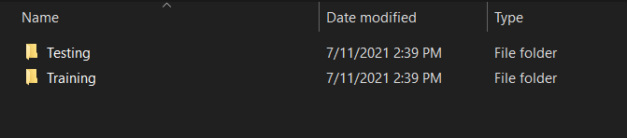

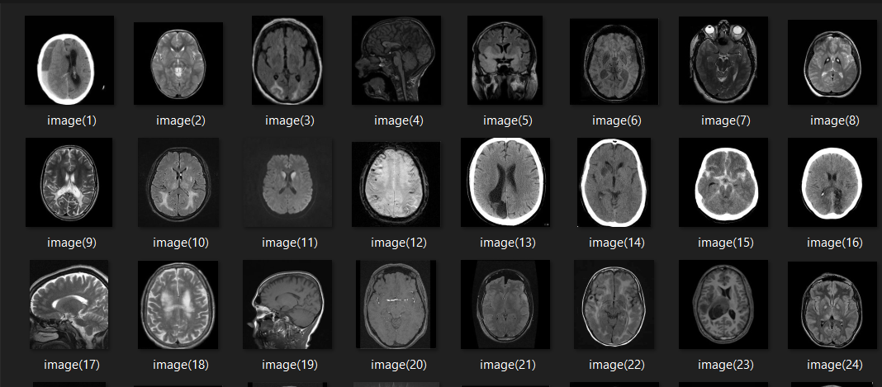

**Code:**

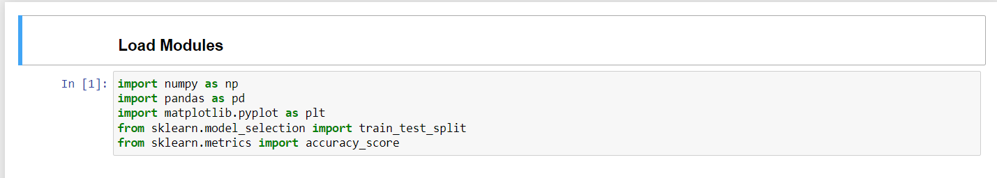

**Output:**

